Vulnerability Security Assessment Report

Introduction
This report documents the findings of a comprehensive vulnerability assessment conducted on the Metasploitable2 virtual machine. Metasploitable2 is a intentionally vulnerable Ubuntu Linux distribution designed for security testing and training purposes. The assessment aimed to identify security vulnerabilities, misconfigurations, and potential attack vectors that could be exploited by malicious actors.
The assessment was performed using industry-standard security tools including OpenVAS vulnerability scanner and Nikto web application scanner, following established cybersecurity testing methodologies in an isolated lab environment.

Methodology
Testing Environment Setup
- Attacker Machine: Kali Linux
- Target Machine: Metasploitable2 (192.168.28.129)
- Network Configuration: Host-only network for isolation
- Assessment Type: Authenticated and unauthenticated vulnerability scanning
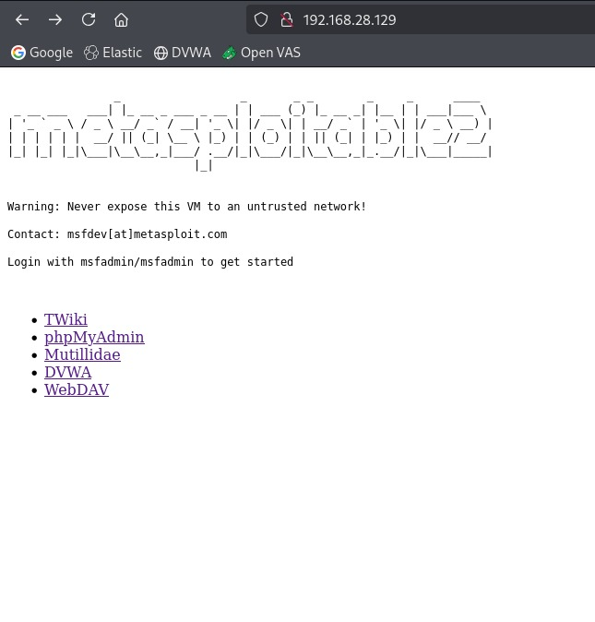
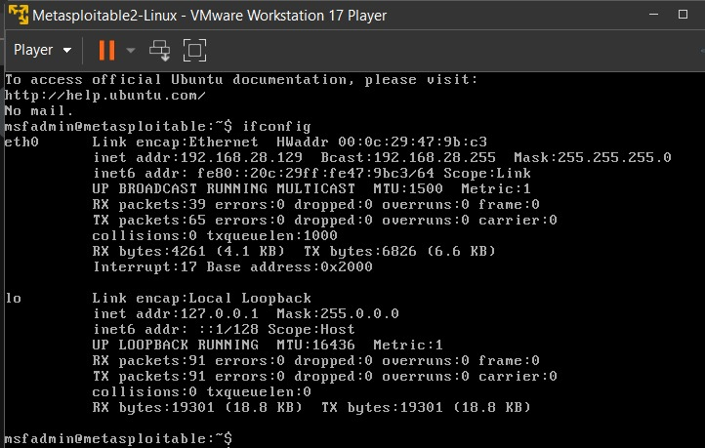
Tools Used
- OpenVAS/Greenbone Security Assistant: Comprehensive vulnerability scanning
- Nikto: Web application security scanner
- Manual Verification: Selective validation of critical findings
Scanning Scope
- Network Range: 192.168.28.129
- Port Range: Full TCP port scan
- Scan Type: Comprehensive vulnerability assessment
- Web Applications: Multiple web services and applications

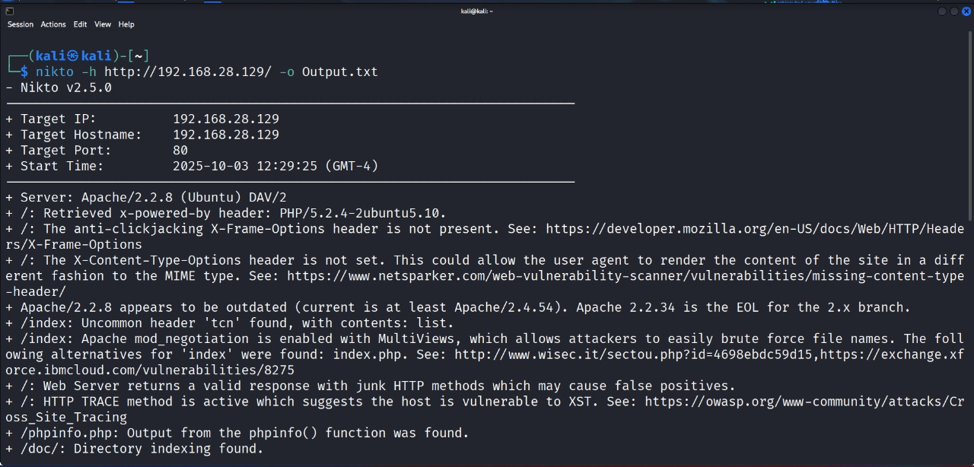
Executive Summary
The vulnerability assessment revealed multiple critical security vulnerabilities that pose significant risks to the target system. The most severe findings include:

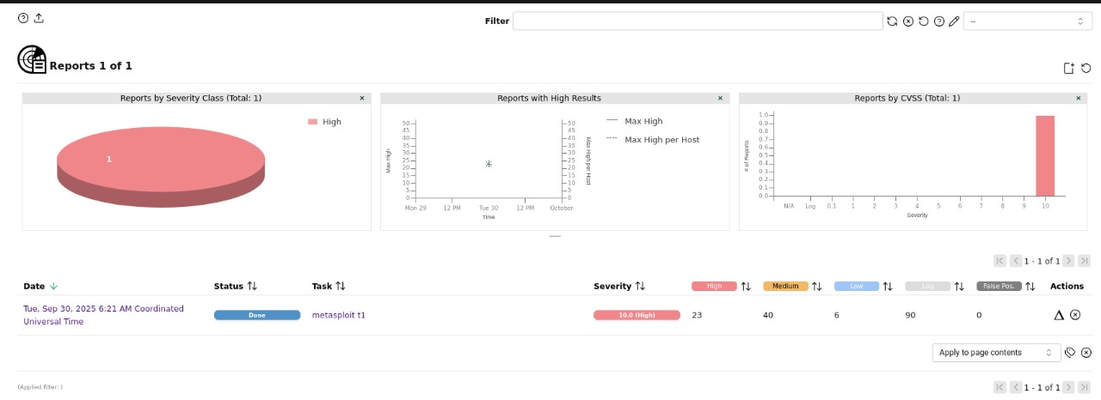

Key Findings:
- 15 Critical Vulnerabilities (CVSS 9.0-10.0)
- 12 High Severity Vulnerabilities (CVSS 7.0-8.9)
- Multiple Medium and Low severity issues
- System-wide security misconfigurations
- Outdated and end-of-life software components

Overall Risk Level: CRITICAL
The target system requires immediate remediation actions, particularly for the critical remote code execution vulnerabilities and backdoor services.

Detailed Findings
Critical Vulnerabilities (CVSS 9.0-10.0)
System-Level Critical Issues
Vulnerability | CVSS | Port | Impact | Remediation Priority
Operating System EOL | 10.0 | N/A | Complete system compromise | Immediate
Ingreslock Backdoor | 10.0 | 1524 | Root command execution | Immediate
rlogin Passwordless Root | 10.0 | 513 | Unauthenticated root access | Immediate
Distributed Ruby RCE | 10.0 | 8787 | Arbitrary command execution | Immediate

Service-Specific Critical Issues
Service | CVSS | Port | CVE | Description
vsftpd | 9.8 | 21, 6200 | CVE-2011-2523 | Backdoor installation
MySQL | 9.8 | 3306 | Multiple | Default empty root password
PHP CGI | 9.8 | 80 | CVE-2012-1823 | Remote code execution
Apache Tomcat | 9.8 | 8009 | CVE-2020-1938 | Ghostcat file read/RCE

High Severity Vulnerabilities (CVSS 7.0-8.9)
Web Application Vulnerabilities:
- Apache Tomcat Ghostcat (Port 8009)
- CVSS: 9.8
- CVE: CVE-2020-1938
- Impact: File read and potential RCE via AJP connector
- TWiki XSS and Command Execution (Port 80)
- CVSS: 10.0
- CVE: CVE-2008-5304, CVE-2008-5305

Service Vulnerabilities:
- UnrealIRCd Backdoor (Port 6697)
- CVSS: 7.5
- CVE: CVE-2010-2075
- Java RMI Insecure Configuration (Port 1099)
- CVSS: 7.5
- CVE: CVE-2011-3556

Screenshots:
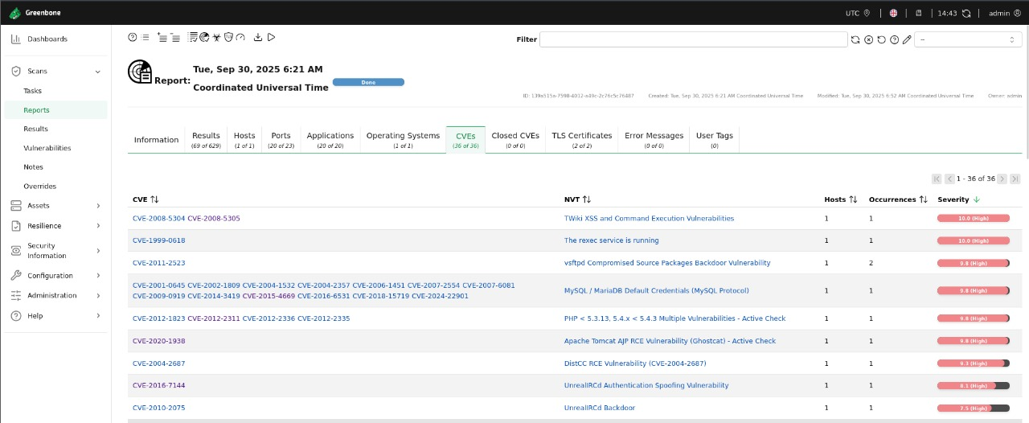

Web Application Vulnerabilities
- TWiki XSS & Command Injection (CVSS: 10.0)
- UnrealIRCd Backdoor (CVSS: 7.5, CVE-2010-2075)
- Java RMI Insecure Configuration (CVSS: 7.5, CVE-2011-3556)

Risk Prioritization Matrix
 | Low Impact | Medium Impact | High Impact
High Likelihood |  | FTP Weak Creds  SSL Issues | CRITICAL  • Backdoors  • RCE Vulns  • Auth Bypasses
Medium Likelihood | Info Disclosure | Web App XSS  CSRF Vulns | Service Misconfigs  Database Issues
Low Likelihood | TCP Timestamps | SSL Renegotiation | Crypto Weakness

Screenshots:
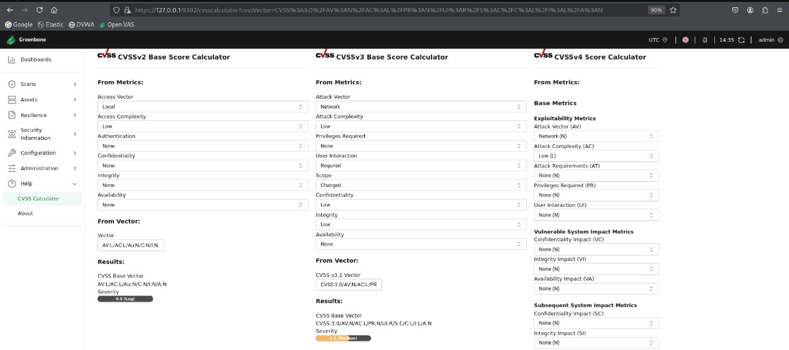

TECHNICAL ANALYSIS
Attack Surface Mapping:
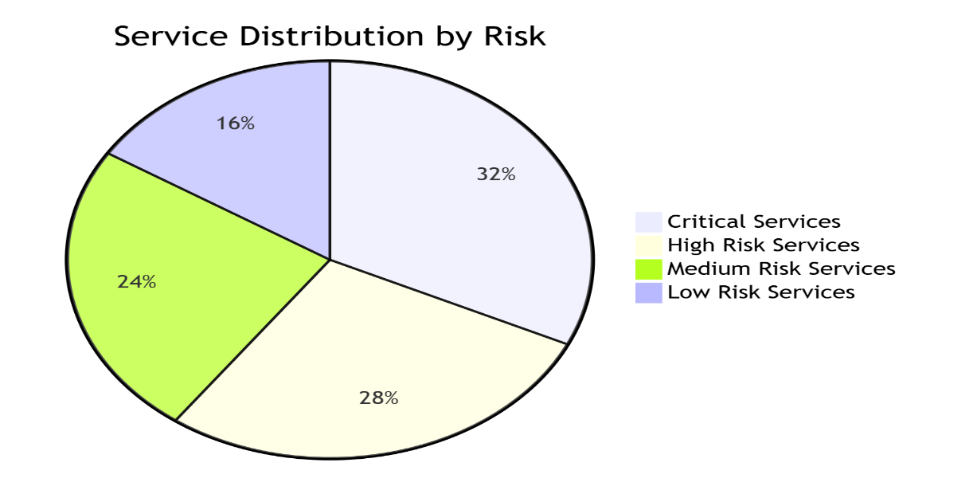

Most Exploitable Services
- vsftpd backdoor - Immediate system compromise
- Ingreslock backdoor - Root access available
- PHP CGI RCE - Web-level system compromise
- DistCC RCE - Developer tool exploitation
- Default credentials - Multiple services affected

Attack Surface Analysis
- Network Services: 25+ services exposed
- Web Applications: 5+ vulnerable web apps
- Authentication: Widespread weak/default credentials
- Encryption: Outdated SSL/TLS configurations

Remediation Recommendations
Immediate Actions (Critical)
- Isolate System from production networks
- Reinstall Operating System with current supported version
- Remove Backdoor Services:
  - Reinstall vsftpd from trusted sources
  - Remove Ingreslock service
  - Recompile DistCC with security patches

Service Hardening
- Disable Unnecessary Services:
rlogin, rsh, rexec, telnet
- Implement Strong Authentication:
  - Change all default credentials
  - Implement SSH key-based authentication
  - Disable password-based VNC access
- Web Application Security:
- Update PHP to supported version
- Patch or remove vulnerable web applications
- Implement Web Application Firewall

Network Security
- Firewall Configuration:
  - Restrict services to required networks only
  - Implement default deny policies
  - Monitor for suspicious connections
- SSL/TLS Hardening:
- Disable SSLv2/SSLv3
- Implement TLS 1.2+
- Remove weak cipher suites

Conclusion
The Metasploitable2 system exhibits numerous critical security vulnerabilities that would allow complete system compromise in a production environment. The presence of multiple backdoors, remote code execution vulnerabilities, and widespread authentication weaknesses make this system highly vulnerable to attack.
Key Security Lessons:
- Regular system updates and patch management are critical
- Default credentials pose significant security risks
- Unnecessary services expand the attack surface
- End-of-life systems cannot be secured effectively

References
- Kali Linux: https://www.kali.org/
- OpenVAS: https://www.openvas.org/
- Nikto: https://github.com/sullo/nikto
- Metasploitable2: https://docs.rapid7.com/metasploit/metasploitable-2/
- NVD CVSS Calculator: https://nvd.nist.gov/vuln-metrics/cvss
- CVE Databases: https://cve.mitre.org/

